Final stage impact assessment
Higher Education: Tuition fee and loan limits for students eligible for home fee status in England, academic year 2025/26

Title:
Secondary Legislation
Type of measure:
Department for Education
Department or agency:
N/A
IA number:
RPC-DfE-24015-IA(1)
RPC reference number:
monica.sankoli@education.gov.uk

Contact for enquiries:
14th January 2025
Date:

Background
Higher education (HE) policy is a devolved matter with each nation of the UK having its own policies with regards to tuition fees, funding and student finance. In this impact assessment, we consider the expected impacts on HE students and providers in England only.
Tuition fee and loan limits
Tuition fees are the amount of money paid by students to HE providers to cover the costs of teaching. Tuition fees for students with home fee status enrolled at an English HE provider were introduced for the 1998/99 academic year and originally fixed at £1,000.
The maximum tuition fee limit for students with home fee status enrolled on a full-time undergraduate course at a HE provider in England was raised to £3,000 in 2006/07 and then to £9,000 in 2012/13 as part of wider reforms to increase funding into the English HE sector and place it on a more financially secure and sustainable footing. Maximum tuition fees were raised to the current level of £9,250 per academic year in 2017/18 .
Since 2006/07 eligible students with home fee status can choose to take out a tuition fee loan to cover the upfront cost of tuition. Tuition fees are paid directly to the provider by the Student Loans Company (SLC) in three instalments (per academic year) with the value of the loan then repaid by the student once they are earning above the relevant minimum repayment threshold, which is based upon the amount they earn. This system ensures that HE tuition is free at the point of access for students taking out the full loan, and that the upfront cost of study does not act as a barrier to participation.
Higher Education providers registering with the OfS can register under the ‘Approved’ or ‘Approved (fee cap)’ category. Under the ‘Approved (fee cap)’ category, providers can charge tuition fees up to the statutory fee limit and are eligible for additional grant funding. Under the ‘Approved’ category, there is no statutory tuition fee limit, though there is a limit on the tuition fee loan that can be claimed by students.
Different fee limits apply depending on the type of provider, the mode of study, where the student is studying during an academic year and duration of course. Under the Education (Student Support) Regulation 2011, as amended, eligible students can apply for a tuition fee loan up to the limit (depending on the actual fee charged) if they are undertaking full-time, full-time accelerated and part-time courses at an Approved (fee cap provider) which has both an access and participation plan to support disadvantaged students and a Teaching Excellence and Student Outcomes Framework (TEF 2023) award (gold, silver or bronze) for teaching quality.
Lower tuition fee limits (referred to as the basic fee amount) apply if students are enrolled at an Approved (fee cap) provider without either or both an access and participation plan and TEF 2023 award. Lower tuition fee loan limits also apply if students are enrolled at a HE provider registered with the OfS as an Approved provider. Current maximum tuition fees and fee loans for academic year 2024/25 are set out in Table 1 below.
Table 1: Maximum fee limits in AY 2024/25 at Approved (Fee Cap) Providers in England with (and without) an OfS Access and Participation Plan.
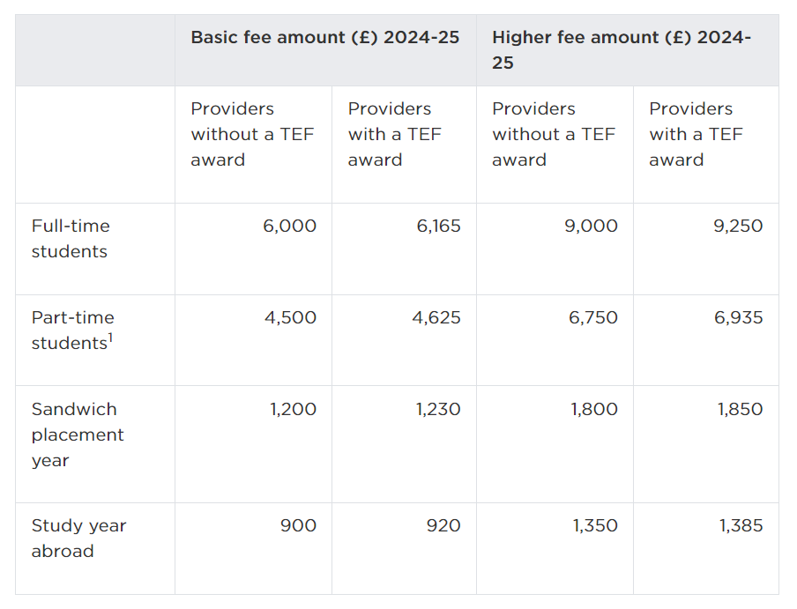
Source: https://www.officeforstudents.org.uk/for-providers/equality-of-opportunity/access-and-participation-plans/fee-limits/

The HE funding model in England
The teaching of UK domiciled undergraduate students at Approved (fee cap) providers in England is funded by a combination of income from tuition fees paid by the student and top-up funding called the Strategic Priorities Grant (SPG). The SPG is allocated to HE providers via the Office for Students (OfS), the independent regulator for HE in England, and is used to help fund the teaching of higher cost courses and students. Approved providers are not eligible for SPG funding.
The cost of HE is shared between the student and the taxpayer, and the balance of contributions has changed over time. The HE reforms of 2012/13 resulted in a significant shift in the way the teaching of UK domiciled undergraduates at Approved (fee cap) providers in England is funded away from direct teaching grants paid by the taxpayer to tuition fees paid by the student (see Figure 1 below).
The taxpayer is forecast to subsidise 29% of the full-time undergraduate higher education Plan 5 loans issued in financial year 2023-24. This is because outstanding student loan debt is written off after a fixed period (40 years for Plan 5 loans). This is known as the Resource Accounting and Budgeting (RAB) charge, and represents the estimated cost to the taxpayer of borrowing to support the student finance system.
Figure 1: Total HE Sector Income by Proportions of Total, 2011/12 – 2022/23

Source: DfE analysis of HESA finance data

1. Summary of proposal
Maximum tuition fee (and loan) limits for new and continuing students with home fee status at HE providers registered with the Office for Students, the independent regulator for HE in England, will be increased by forecast inflation (3.1%) in academic year 2025/26. This will mean that the maximum tuition fee cap for full-time courses will rise to £9,535.

2. Strategic case for proposed regulation

Problem Under Consideration
The HE reforms of 2012/13, which included raising tuition fee caps to £9,000, were aimed at increasing funding into the HE sector in England and placing it a more financially secure and sustainable footing. Since then, the maximum fee limit for full-time undergraduates has remained virtually unchanged, rising only once to the current level of £9,250 in 2017/18.
Over that time, due to inflation, the real value of the tuition fee has declined steadily. In 2012/13 prices the current £9,250 fee is worth an estimated £5,860 in 2024/25, a fall of around 37%.
Figure 2: High fee cap for full-time undergraduates in nominal and real prices
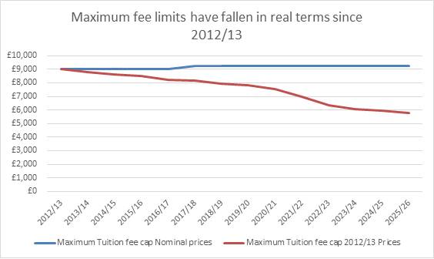
Source: DfE analysis

Combined with rising student numbers, the declining value of the tuition fee income due to inflation has meant that the total value of income per student which HE providers have available to fund the teaching of UK domiciled students has fallen steadily in real terms since 2015/16, the peak year in funding per student (see Figure 3). In its 2024 financial sustainability report, the OfS estimated that in real terms the value of income for teaching UK students was approximately 25% lower than it was in 2015-16 and is approaching its lowest level since the late 1990s (Figure 3).
Figure 3: Teaching unit of resource (fees and grant per full-time equivalent student eligible for UK fees), valued in real terms at 2022-23 prices
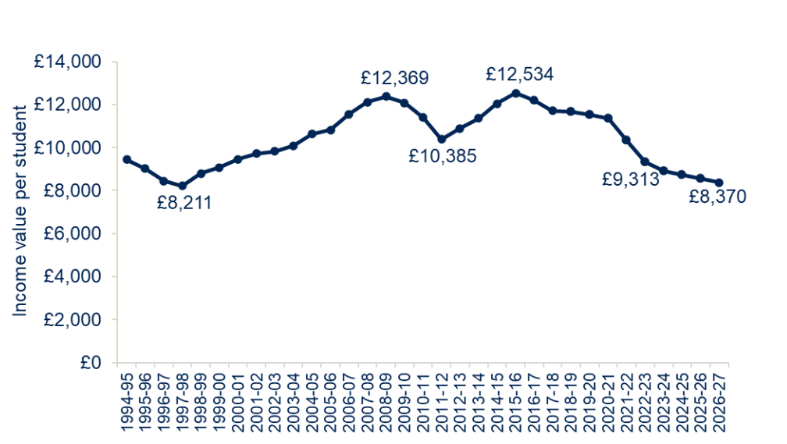
Source: https://www.officeforstudents.org.uk/media/ly1buqlj/financial-sustainability-report2024.pdf

The HE sector is facing greater and wide-ranging financial challenges including: higher staff pay and increased pension and employer national insurance contributions, rising operating, construction and energy costs due to higher inflation, and the increase in financial support for students experiencing hardship due to the recent cost of living crisis. In addition to these growing cost pressures, many HE providers are needing to invest significantly in improving the environmental performance and sustainability of their buildings and infrastructure to reduce their net carbon emissions and meet their net zero targets.
The decline in the real value of the tuition fee coupled with rising costs has meant that much of the HE sector as a whole, and the teaching of UK domiciled students in particular, is increasingly in deficit. According to published analysis by the OfS, publicly funded teaching activity (i.e. UK domiciled students) at 128 universities in England and Northern Ireland (which accounts for the majority of HE sector income and expenditure) recorded a deficit of some £1.44bn in 2022/23, representing around 10.6% of total income for that sub-group (Figure 4).
Figure 4: TRAC full economic cost surplus/(deficit) by activity, 2022-23 (higher education institutions in England and Northern Ireland)
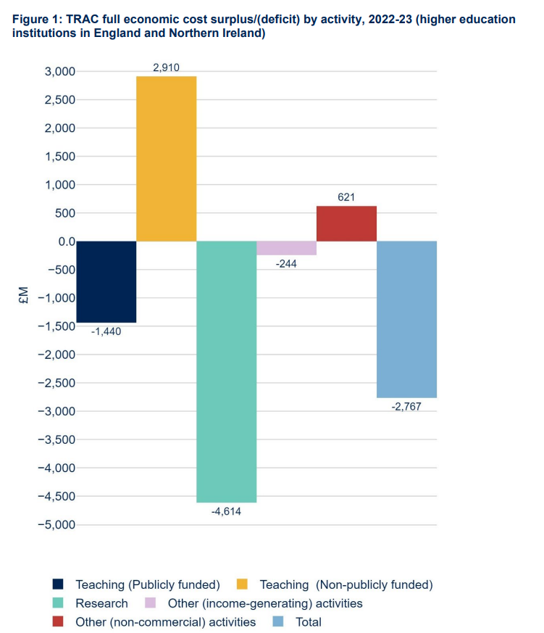
Source: https://www.officeforstudents.org.uk/media/lqjivwol/annual-trac-2022-23-update-july-2024.pdf
In its most recent annual assessment on the financial sustainability of the HE sector, published in May 2024, the Office for Students (OfS) reported that the financial performance of the sector was weaker in 2022/23 than 2021/22 and is expected to decline further in 2023-24, with 40% of providers expecting to be in deficit.
In response to the growing financial challenges that the HE sector is facing there are reported examples of some HE providers taking action to reduce the costs they incur and improve their financial position, some of which could ultimately have a negative impact on students’ learning and experience. In the last year there have been examples of job losses at some HE providers with others closing down certain courses, degree programmes or even entire faculties and departments with around 70 providers across the UK running restructuring and redundancy programmes.
Raising tuition fees is therefore needed to improve the financial sustainability of teaching UK domiciled students and of HE providers and the sector as a whole. Without action, continued reductions in the real value of tuition fees, against a backdrop of rising costs, could put at further risk student outcomes – for example reducing the number and range of courses available to some students and eroding the quality of teaching and the wider learning experience that students receive. There would also be an increasing risk of some providers exiting the sector, with associated consequences for students.
Research in UK universities is heavily dependent on cross subsidy from international student fees. High quality research activity at some HE providers may therefore also be at risk if they need to increasingly divert any financial surpluses from international students away from funding research to subsidising the teaching of UK domiciled students.

3. SMART objectives for intervention
The government recognises and values the benefits of HE to the local and national economy and recognises the benefits of attending HE to the graduate. IFS research shows that a graduate, on average, can expect to earn £100,000 more over the course of their working life compared to a similar person who doesn’t pursue HE.
However, the Government also recognises that HE providers have constrained income sources and that increasing costs are putting the sector under increasing financial strain.
Increasing tuition fee limits by forecast RPIX, would affect students eligible for home fee status, including those funded by SLC tuition fee loans, studying at an HE provider registered with the Office for Students (OfS) in England. In 2022/23, there were some 1.5m UK domiciled undergraduate students in England with around 1.15m English domiciled students taking out a full-time undergraduate tuition fee loan. Total UK tuition fee income received by English providers was around £12.5bn of which some £9.6bn was from students funded by the SLC and other public authorities.
The intended effects and outcomes of increasing tuition fees and loan limits can be considered specific, measurable, achievable, realistic and time-limited (SMART).
The policy objective is to maintain the real terms value of tuition fees for the next academic year (2025/26) to support financial sustainability of the sector and the quality of teaching provision available.
A key measure of success will be that HE providers transform their business models in a financially sustainable way and we do not see a deterioration in the quality of teaching provision because HE providers perceive they have insufficient resources. An inflationary increase in tuition fees for eligible home fee status students would allow for a steady state position with regards to this income in the next academic year.
We recognise that UK tuition fee income represents only a portion of HE providers’ overall income (in 2022/23, UK tuition fee income was 28% of all income for HE providers in England) and other factors will therefore influence whether the policy objectives are achieved. The Office for Students monitor the financial health of the HE sector.
This objective also links to HMG objectives around growth – see logic map in next section.

4. Description of proposed intervention options and explanation of the logical change process whereby this achieves SMART objectives

Option 1: Tuition fee limits raised for AY 2025/26 by setting cash amounts (based on forecast inflation) – secondary legislation (Preferred option)
Maximum tuition fee (and loan) limits for UK and Irish domiciled undergraduate students at a registered HE provider in England are set out in legislation. Secondary legislation would be laid to set fee limits in cash terms for AY 2025/26, increasing undergraduate tuition fee limits (for students undertaking full-time, full-time accelerated and part-time courses) for UK domestic students (at English providers only) based on forecast RPIX (All IHE tems Retail Price Index (RPI) excluding mortgage interest payments) inflation (2026 Q1).
As an example, for 2024/25, the maximum amount a provider in England with a Teaching Excellence and Student Outcomes Framework (TEF) 2023 award and an access and participation plan can charge a full-time undergraduate UK student is £9,250. Uprating by the RPIX forecast inflation for 2026 Q1 of 3.1%, (Autumn Statement OBR forecast) this would mean that maximum tuition fees for these students would increase by £285 to £9,535 for academic year 2025/26, which would apply to both current and new students. This method for increasing fees would apply to all fee limits (full-time, full-time accelerated and part-time courses).
This change would affect the Devolved Administrations (DAs) equivalent funding for HE. DAs could choose to increase the fee loans that they make available to students from the DAs studying in England (to match the new fee limits). The DAs set their own fee limits for English students studying at providers in Scotland, Wales or Northern Ireland and their HE providers would be able to benefit from additional fee income if the DAs chose to apply the same percentage increase to fee limits for English domiciled students that had been applied by the Westminster Government. This impact assessment considers only the expected impacts on English HE providers and does not consider the expected impacts on the devolved nations.
Figure 5 presents the logic map of how an increase in domestic undergraduate tuition fees flows through to the activities, outputs, outcomes and impacts of this change. Raising fees would maintain funding levels in real terms which would allow HE providers to maintain levels of spending on teaching related activities such as staff, course content and teaching facilities. This, in turn, would lead to HE providers being able to continue their current offer of high-quality courses to students across a variety of subjects. Overall, a fee increase would help mitigate against the current financial pressures the sector is facing. The logic model sets out the positive impacts this could have on HE provider behaviour.
Figure 5: Logic map of increase in fee limits (input) to impacts
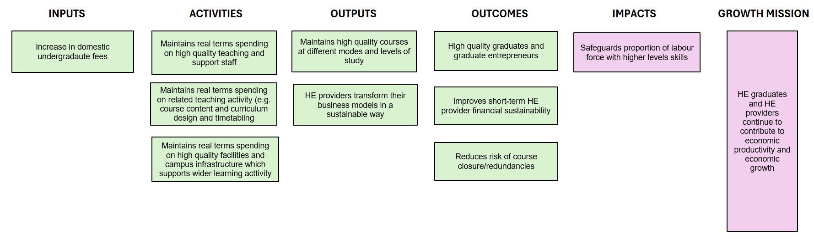

5. Summary of long-list and alternatives
The following criteria and objectives have been applied to assess each option in the long and short list, considering whether each option:
- Leads to increased funding to HE providers to support financial viability and delivery of high-quality teaching and learning
- Helps maintain high quality and choice of HE provision for students
- Ensures access to HE for students is not restricted on the basis of affordability
- Ensures affordability to the taxpayer

Long list and alternative options that have been considered
Option 0: Do nothing
Maximum level of tuition fees for a standard full-time undergraduate course will remain at £9,250 per year for academic year 2025/26
Option 1: Tuition fee limits raised for AY 2025/26 (preferred option)
Maximum tuition fee limits would be raised by RPIX forecast inflation for 2026 Q1 (3.1%) which would mean that the maximum fees for UK domiciled students would increase by £285 to £9,535 for academic year 2025/26. No policy decisions have yet been made regarding fee levels for AY26/27 onwards. We therefore assume for the purpose of this impact assessment that tuition fee and loan limits remain fixed at academic year 25/26 levels for the remainder of the 10-year appraisal period.
Option 2: Non-regulatory option (uncapped fees) – Rejected
Under a potential option involving an extensive regulatory overhaul, price cap regulation would be completely removed meaning that HE providers would be free to charge tuition fees at whatever level they chose appropriate. Under this option, tuition fees at many HE providers would likely be set above the current maximum fee limit.
This would result in a situation whereby access to HE would be based on the ability to pay rather than the ability to learn. Faced with potentially higher fees that are unregulated, there’s a risk that students who are comparatively more debt averse (e.g. disadvantaged students) could be less likely to pursue HE because they deem it too costly, even though they would benefit from it. Although historical data shows entry rates to HE for those from disadvantaged backgrounds follow the same trend as those from more advantaged backgrounds when previous capped tuition fees increased, it is less certain how these trends would be for an uncapped fee system, where the risk of a disproportionate impact could be higher.
A system of uncapped tuition fees with uncapped loans would also be less affordable for the taxpayer since it would increase the amount of total fee loan outlay on student support at a time when student numbers are projected to grow further and public finances are recovering from recent shocks to the UK economy. If the cap still applied to the loans but not the fee limits, there is a risk that some students would not be able to afford to pay the shortfall at HE providers charging over the loan limit, thereby essentially creating a tiered system in HE where students from disadvantaged backgrounds would unfairly face a more restricted set of choices when applying to HE.
For these reasons, the non-regulatory option has been rejected.
Option 3: Alternative options (increasing the cap by an amount greater than inflation) – Rejected
Increasing fees to a level above inflation would benefit HE providers’ financial viability and ensure they have the resources to deliver high quality teaching and learning. It would also help maintain choice and diversity of HE provision for students.
However, it would come at a cost to students, particularly those that are more debt averse, who would be less likely to pursue HE because they deem it too costly, even though they would benefit from it. It is difficult to say with certainty the direction of impact as entry rates for advantaged and disadvantaged students have followed similar rates historically.
Increasing fees to a level above inflation would also mean an increased cost to the taxpayer as the government subsidises the cost of higher education for students which would affect the affordability to the taxpayer.

Option 4: Alternative options (increasing Strategic Priority Grant (SPG) funding, rather than raising fees) – Rejected
This would involve changing the way the teaching of undergraduate courses for UK domiciled students is funded through a mix of tuition fees paid by the student and top-up direct SPG funding paid via the OfS, the regulatory body for HE in England.
At a time when the public finances are in recovery following recent shocks to the UK economy, alternative options which would involve an increase in direct SPG grant funding were rejected on the basis that they would be more costly for the taxpayer.
Table 2: Summary of alternative options and how each meets the policy criteria
Green – full meets objective, Amber – partially meets criteria, Red – does not meet criteria

Criteria | Option 0: do nothing | Option 1: increase fees by RPIX inflation | Option 2: uncapped fees | Option 3: increasing fees by amount greater than inflation | Option 4: Additional grant funding to HE providers
Leads to increased funding to HE providers to support financial viability and delivery of high-quality teaching and learning
Maintains high quality and choice of HE provision for students
Ensures access to HE for students is not restricted on the basis of affordability
Ensures affordability to the taxpayer

6. Description of shortlisted policy options carried forward
The short-listed options are:
- Option 0: do nothing, fees remain frozen; and
- Option 1: Tuition fee limits raised for AY 2025/26 by setting cash amounts (based on forecast inflation) – secondary legislation (Preferred option).

Option 0 – Do nothing, fees remain frozen
Maximum tuition fee and loan limits would continue to be frozen at current levels for academic year 2025/26. This would mean that the maximum level of tuition fees for a standard full-time undergraduate course will remain at £9,250 per year for academic year 2025/26.
The do-nothing option would not require any changes to legislation or delivery to implement. It would not be necessary to amend existing secondary legislation governing new or continuing students for academic year 2025/26, nor would the SLC, which administers student support on behalf of the Department for Education, need to update its systems which it would otherwise do in the event of a rate change.
However, this option would not meet the intended policy objectives to improve HE provider finances to avoid risks to teaching quality and student outcomes and any wider negative impacts.
Option 1: Tuition fee limits raised for AY 2025/26
Maximum tuition fee limits would be raised by RPIX forecast inflation for 2026 Q1 (3.1%) which would mean that the maximum tuition fee and loan limits for students would increase by £285 to £9,535 for academic year 2025/26.
Impact on small and micro businesses
Small businesses are defined in the Better Regulation Framework guidance as those employing between 10 and 49 full-time equivalent (FTE) employees. Micro-businesses are defined as those employing between 1 and 9 employees. Small and micro businesses include voluntary and community bodies (also known as civil society organisations). Medium sized businesses are defined as employing between 50 and 499 staff.
As of October 2024, there are 423 HE providers registered with the OfS²⁸, of which 344 are in the Approved (fee cap) category (Figure 6).
Figure 6: Breakdown of providers from OfS register by registered category and provision type, October 2024, student FTE 2022/23
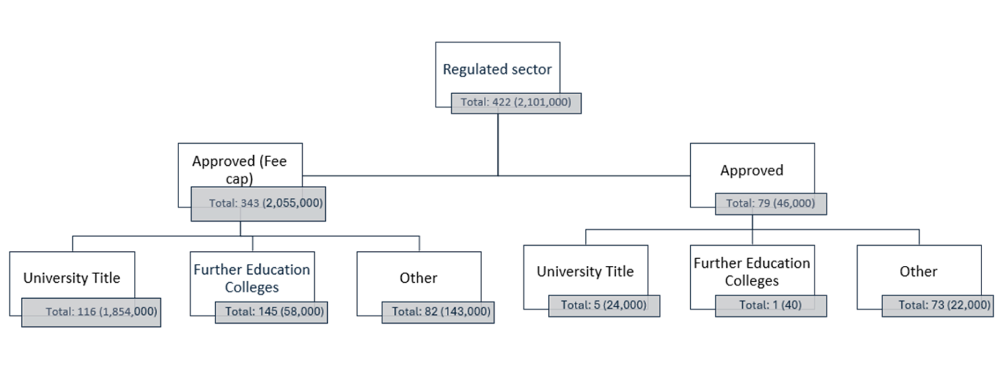
Source: DfE analysis based on OfS data

All HE providers registered with the OfS, excluding Further Education College’s (FECs), are required to submit data on academic staff to HESA. However, data returns on non-academic staff have been voluntary since academic year 2019/20. Given that not all HE providers have reported their non-academic staff numbers for 2022/23, a ratio between academic/non-academic staff from 2018/19 HESA data is used to estimate missing non-academic staff numbers for 2022/23.
While Approved providers on the OfS register are proportionately more likely to be smaller than Approved (fee cap) providers (which includes nearly all the universities), they will not be affected by the increase in tuition fee limits since their fees are uncapped. However, tuition fee loan limits at Approved providers would still increase by forecast RPIX inflation under the preferred option, which could see some increase their fees, where they have set them in line with the loan limit.
Focusing therefore on staff numbers at Approved (fee cap) providers (which will be subject to tuition fee limits) based on the latest available data we estimate that 2% (4) are micro, 14% (26) are small, and 24% (46) are medium sized businesses. Estimates of the average income gained are set out in Table 3 below for the preferred option - option 1 (tuition fees rise by forecast RPIX).

Table 3: Distribution of micro, small, medium and large providers across Approved (fee cap) HE providers
 | Approved (fee cap) | Proportion of Approved Fee Cap | Average Income gained due to fee uplift as a % of total income with no uplift
Micro - Less than 10 | 4 | 2% | 1.2%
Small - Between 10 and 49 | 26 | 14% | 2.6%
Medium - Between 50 and 499 | 46 | 24% | 2.6%
Large - Above 500 | 115 | 60% | 2.3%
Source: DfE analysis of HESA data

This measure is deregulatory in terms of impact on businesses. This is because raising the tuition fee cap to a higher-level means that HE providers will have greater financial resources which will enable them to maintain or spend more on their core activities than they previously were able to. For this reason, we would not exempt micro, small, and medium providers from these regulations.
HE providers have different funding models meaning they are proportionately more reliant on some sources of income and funding than others. Accordingly, maintaining the value of tuition fees for academic year 2025/26 in real terms and the corresponding income thereby generated will proportionately impact some providers more than others. In percentage terms, the financial benefit will be proportionately greater for teaching intensives which tend to be more reliant on undergraduate tuition fee income.
Table 4: Average income gained % under option 1 scenario by student typology.
Student typology | Average income gained %
High tariff | 2.0%
Large Level 4/5 | 2.9%
Low or unknown tariff | 2.5%
Medium tariff | 2.6%
Small Level 4/5 | 3.1%
Specialist: creative | 2.0%
Specialist: other | 2.4%

7. Regulatory scorecard for preferred option
Please provide quantitative estimates and qualitative descriptions of impacts under each heading in the following sections. The right-hand column for directional ratings should be based on the description of impact and the sign of the suggested indicator (NPV, NPSV, all impacts): Green – positive impact, red – negative impact, amber – neutral or negligible impact, blue – uncertain impact. Please use the colours in the examples shown below, as these are suitable accessible colours. Please see BRF guidance technical annex for definitions.

Part A: Overall and stakeholder impacts
(1) Overall impacts on total welfare |  | Directional rating  Note: Below are examples only
Description of overall expected impact | The increase in the real value of tuition fees paid represents an economic transfer from the student to the HE provider and in turn the taxpayer (who funds SLC tuition fees loans up front and subsidises them to the extent that they are not paid back in full).  Therefore, the overall impact on total welfare is expected to be neutral. | Neutral  Based on all impacts (incl. non-monetised)
Monetised impacts | £0 NSPV  An increase in tuition fees will represent a financial benefit for businesses (HE providers), and a cost to students and the taxpayer. The cost to students who take out student loans will be increased loan outlay, which includes both the proportion of loan repaid and unpaid (RAB charge). Students will incur the repaid portion of the loan as the taxpayer incurs the cost of the unpaid loan. | Based on likely £NPSV
Non-monetised impacts | HE providers and the sector as a whole is more financially stable and the quality of teaching and the learning experience is safeguarded.  Reduces the risk that providers will look to reduce quality of provision or choice on offer to students.  Students would benefit from having the same options and choices for study. An increase in tuition fees may help to maintain the quality of teaching provision and accordingly student outcomes. | Neutral
Any significant or adverse distributional impacts? | See sections below | Neutral

(2) Expected impacts on businesses
Description of overall business impact | There will be a positive financial impact to businesses (HE providers), The raising of tuition fee limits can be considered de-regulatory as lifting the tuition fee cap to a higher level means that they will have greater financial resources which will enable them to maintain or spend more on their core activities than they previously were able to. It is estimated that the increase in tuition fees would raise overall tuition fee income to the HE sector by around at least £325million in AY 2025/26. This increase will help to alleviate the financial burden providers are currently facing. | Positive
Monetised impacts | Approx net financial cost to business EANDCB £-332.6m of which admin costs £0. HE providers will benefit from an increase in tuition fee income, therefore the EANDCB is negative.  Business NPV: £2,862.5m across 10-year appraisal period  There may be some indirect administrative burden on HE providers to update their website or other documents with information on the new fee loans and limits. However, we do not see this as additional, as HE providers are assumed to check and update their websites and documentation each year when fee information is confirmed. | Positive  Based on likely business £NPV
Non-monetised impacts | Improves short-term HE provider financial sustainability | Positive
Any significant or adverse distributional impacts? | HE providers have different funding models meaning they are proportionately more reliant on some sources of income and funding than others. Maintaining the real term value of tuition fees for 2025/26 and the income thereby generated will proportionately impact some providers more than others. In percentage terms, the financial benefit will be proportionately greater for teaching intensives which tend to more reliant on undergraduate tuition fee income  See SaMBA section | Neutral

(3) Expected impacts on households
Description of overall household impact | We assume students are households for this assessment.  Impact to students – Increasing the maximum tuition fees for academic year 2025/26 will be a nominal increase in the cost to students by around £285 for each year of study, assuming fees remain frozen at that level from academic year 2026/27 onwards. However, tuition fees would be the same value in real terms as in academic year 2024/25.  The increase in the real value of tuition fees paid represents an economic transfer from the student to the HE provider and in turn the taxpayer (who funds SLC tuition fees loans up front and subsidises them to the extent that they are not paid back in full).  Monthly repayments will not increase for any borrower because repayment rules aren’t changing, repayments are still based on the same percentage of earnings over the same threshold as before the fee increase. Any additional debt repaid will be in the form of a short amount of extra time added to the time spent in repayment. Loan balances will still be written off 40 years after Statutory Repayment Due Date (SRDD)/graduation so any borrower who wouldn’t have repaid within 40 years will repay the same amount even with fee increases; a greater balance will be written off at the end of their term. | Negative
Monetised impacts | All students face an increase in tuition fees which is an economic transfer from students to HE providers. For SLC borrowers, an increase in the tuition fee limit will mean that total fee loan outlay paid out by the Exchequer on behalf of the student will be higher. The total outlay cost of a fee increase is estimated at £331m in academic year 2025/26. This figure is not directly comparable with the provider impact figures due to the different modelling assumptions used to calculate each.  Students do not pay their loans off in full. The Resource Accounting and Budgeting (RAB) charge is the estimated cost to Government of borrowing to support the student finance system. It is based on future loan write-offs and interest subsidies in net present value terms. For convenience, we express these costs as a proportion of the initial loan outlay, which is currently 29% for Plan 5. For 2025/26, students are estimated to pay back £200m (on the assumption that £131m is the RAB charge element).  The regulation does not require students to do anything new compared with the counterfactual, therefore there will be £0 admin costs. | Negative  Based on likely household £NPV
Non-monetised impacts | Students may benefit from having the same options and choices for study. An increase in tuition fees may help to maintain the quality of teaching provision and accordingly student outcomes. | Neutral
Any significant or adverse distributional impacts? | The lowest earners (after graduation) will have their loans written off regardless of the loan balance they have. The highest earners will pay their loan off faster and so accrue less interest than middling earners who still pay off their entire loan. The rate at which borrowers repay their loans will not be affected by this policy so while in repayment, the monthly cost of repaying the loan will remain the same. For those who do fully repay, the additional loan balance is repaid as additional time at the end of repayments (up to the 40-year limit) rather than increasing monthly outgoings soon after graduation  There is a risk that the increased loan balance may be off-putting to some potential applicants, particularly those from more deprived backgrounds. It is unclear, however, what effect if any this greater debt adversity has on participation decisions. Since tuition fees will remain unchanged in real terms, we do not expect there to be a significant impact. These impacts will be covered separately by an Equalities Impact Assessment (EIA), due to be published alongside this Impact Assessment. | Uncertain

Part B: Impacts on wider government priorities
Category | Description of impact | Directional rating
Business environment:  Does the measure impact on the ease of doing business in the UK? | The measure is not expected to impact on the ease of doing business in the UK. The measure involves increasing the tuition fee limit for an existing product (undergraduate higher education), rather than introducing any new products.  We have considered whether an increase in the tuition fee limit may incentivise some Approved providers to register in the Approved (fee cap) category, or whether it might encourage unregistered providers to now join the OfS register under any registration category. Our assessment is that the increase in fees is relatively small compared with the costs of registration, and therefore unlikely to have an impact on HE providers switching registration category or their decision to register with the OfS. For example, the fee for a Quality and Standards assessment before making a decision on registration is currently £28,463, which is only one part of the registration process. Additionally, there is a requirement to recruit an independent member of the governing body if a provider is in receipt of OfS or UK Research and Innovation (UKRI) funding which would involve costs. | Neutral
International Considerations:  Does the measure support international trade and investment? | While increasing tuition fees limits for academic year 2025/26 only directly affects UK domiciled students, there could be an indirect positive impact on trade and investment if providers invest in teaching and learning, making it attractive for international students to study in the UK. This is because expenditure by international students on tuition fees is treated as an export in the national accounts as it represents spending in the country by a non-UK resident. | Neutral
Natural capital and Decarbonisation:  Does the measure support commitments to improve the environment and decarbonise? | This measure involves increasing tuition fee income for HE providers, which we assume will be spent on teaching related activities such as staff, course content and teaching facilities. Therefore, we do not expect this measure to directly affect the environment.  It may indirectly benefit the environment if HE providers choose to spend the additional income on maintaining campus grounds (which can include natural areas and playing fields), or choose to invest in improving the energy performance and sustainability of their buildings (some of which may be energy inefficient because of their age) and therefore lowering the overall level of carbon emissions and waste generated by the HE provider’s academic facilities and residences.  However, this assessment is highly uncertain as HE providers are independent and autonomous organisations that are responsible for managing their assets (including the capital estate) and making their owns decisions about how to spend the income they receive, including from tuition fees. | Neutral

8. Monitoring and evaluation of preferred option
The Department for Education is committed to evidence-based policy making through effective monitoring and evaluation.
The OfS, as the independent regulatory body for HE in England, is responsible for monitoring the financial performance HE providers. The OfS collects wide-ranging information from individual HE providers including audited financial statements and student and finance forecasts as well as intelligence from key sector stakeholders and other organisations. This information is used to inform the OfS’s ongoing assessment of the financial sustainability of the HE sector and individual HE providers.
The following criteria and objectives have been applied to assess each option in the long and short list, considering whether each option:
- Leads to increased funding to HE providers to support financial viability and delivery of high-quality teaching and learning
- Maintains high quality and choice of HE provision for students
- Ensures access to HE for students is not restricted on the basis of affordability
- Ensures affordability to the taxpayer
Sector bodies collect and publish a wide range of data on different aspects of HE in England which will help policy makers to monitor the impact and effectiveness of policy changes against their objectives. ​The policy will be assessed on how this set of criteria has been met through desk-based analysis of the following:
- Analysis of Transparent Approach to Costing (TRAC) data. TRAC is an activity-based costing system which is used by HE providers to understand the costs of their activities (Teaching, Research and Other activities). All HE providers (not FE colleges) who receive public funding are required to produce an annual TRAC return by end of January each year. This information will be used to assess the impact of the tuition on the deficit in publicly funded teaching (UK students) at HE providers and the sector overall.
- The Higher Education Statistics Agency (HESA) and Office for Students compile a wide range of data on students (including what and where they study, their personal characteristics and outcomes) and HE providers (including their income, expenditure and financial position). This information can be used to understand and compare the impact of policy changes on different groups of students and types of HE providers.
- UCAS data on applications and entry rates to HE by all students, and in particular disadvantaged students, can be used to assess whether the policy has influenced the decision-making behaviour of prospective students and whether the impact has been comparatively greater for some groups of students.

- Analysis of the SLC data on student loan borrowers and outlay can be used to assess the impact of policy changes on the number of students taking out a loan and any financial impacts to the Exchequer. Our modelling assumptions are clearly set out in the annex, and these can be tested against final outcomes for 2025/26.
Together 1-4 will enable an assessment of whether there have been unintended consequences for HE providers or students.
The main external factor that may influence the impact of additional tuition fee income on the delivery of high-quality teaching and learning are the decisions that HE providers make as independent autonomous institutions about how to spend the income they receive from tuition fees. However, given the size of the deficit HE providers have been carrying on publicly funded teaching, we think this risk is low. Historically, most HE providers have charged the maximum limit, so they will likely take advantage of this additional uplift.
We recognise that UK tuition fee income is only a portion of providers’ overall income (in 2022/23, UK tuition fee income was 28% of all income for HE providers in England) and other factors will therefore influence whether the policy objectives are achieved. The Office for Students monitor the financial health of the HE sector.
In line with the Better Regulation Framework, the Department will also undertake a post-implementation review. As the fee increase will not be in place until the academic year 2025/26 and there will be a lag in the data necessary to conduct such a review, we do not anticipate this happening until after 2028.

9. Minimising administrative and compliance costs for preferred option
Administrative burdens of complying with this regulation are assessed to be low. The regulation is related to tuition fee loans and limits. The regulation itself does not directly affect the roles and responsibilities of HE providers or the activities that they carry out. There may be some indirect administrative burden on HE providers to update their website or other documents with information on the new fee loans and limits, however, we do not see this as additional, as HE providers are assumed to check and update their websites and documentation each year when fee information is confirmed.
The regulation also does not require students to do anything new compared with the counterfactual.

Declaration

Department:
Department for Education

Contact details for enquiries:
https://form.education.gov.uk/service/Contact_the_Department_for_Education

Minister responsible:
Bridget Phillipson

I have read the Impact Assessment, and I am satisfied that, given the available evidence, it represents a reasonable view of the likely costs, benefits and impact of the leading options.

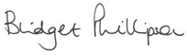
Signed:

15.01.2025
Date:

Annex A: Detailed assumptions and analysis of short listed options
Option 0 – Do nothing: fees remain frozen at current levels
Under the do-nothing option, tuition fees and loans would remain frozen at their current levels. This would mean £9,250 per academic year for a standard full-time undergraduate course at an Approved (fee cap) HE provider (with an access and participation plan and a TEF award) on the OfS register.

Option 1 - Tuition fee limits raised for AY 2025/26 by setting cash amounts (based on forecast inflation) – secondary legislation (Preferred option)
Secondary legislation to set fee limits in cash terms for AY 2025/26, increasing undergraduate tuition fee limits (for students undertaking full-time, full-time accelerated and part-time courses) for domestic students (at English providers only) based on forecast RPIX (all items Retail Price Index (RPI) excluding mortgage interest payments) inflation for 2026 Q1 (from the OBR’s Autumn Statement). This would mean current tuition fees of £9,250 per academic year for a standard full-time undergraduate course would increase by 3.1% to £9,535 in 2025/26 and remain fixed at this level.
Impact on students
The maximum fee cap for full-time undergraduates has remained relatively fixed since it was increased to £9,000 for academic year 2012/13, rising only once to the current level of £9,250 in 2017. Over that time, due to inflation, the real value of the tuition fee has declined. In 2012/13 prices the current £9,250 fee is worth an estimated £5,860 in 2024/25, a fall of around 37%.
Increasing maximum tuition fees for academic year 2025/26 would represent a nominal increase in the cost to students by around £285 for each year of study, assuming fees remain frozen at that level from academic year 2026/27 onwards. However, tuition fees would be the same value in real terms as in academic year 2024/25.
Self-funded students will pay higher fees upfront. Students who rely on SLC loans to fund their studies will be unaffected financially in the short term by fee increases. Students’ fee loans will increase to cover any increase in fee charged, meaning that student loan balances will be higher, but they still will not be obligated to repay anything before they graduate.
Monthly repayments will not increase for any borrower because repayment rules are not changing, repayments are still based on the same percentage of earnings over the same threshold as before the fee increase. Any additional debt repaid will be in the form of a short amount of extra time added to the time spent in repayment. Loan balances will still be written off 40 years after Statutory Repayment Due Date (SRDD) graduation so any borrower who wouldn’t have repaid within 40 years will repay the same amount even with fee increases; a greater balance will be written off at the end of their term.
The increase in the real value of tuition fees paid represents an economic transfer from the student to the HE provider and in turn the taxpayer (who funds SLC tuition fees loans up front and subsidises them to the extent that they are not paid back in full).
Students may benefit if the tuition fee uplift help ensure they have the same options and choices for study. An increase in tuition fees may help to maintain the quality of teaching provision and accordingly student outcomes. However, this outcome is uncertain as providers may continue with deficit reduction activities overall which could also impact teaching provision.
There is a risk that the increased loan balance may be off-putting to some potential applicants, particularly those from more disadvantaged backgrounds. However, the extent of this occurring is not certain given this is a marginal fee increase adding to already large loan amounts.
UCAS data indicates that entry rates from UK domiciled students to UK universities have generally continued to increase overtime tend to recover from any shocks to the system such as increasing tuition fees. Figure A-1 overleaf shows a temporary dip in entry rates in 2012 (when tuition fees rose from £3,000 to £9,000), and a smaller temporary decrease in 2018 (when fees were raised from £9,000 to £9,250).
Similarly, Figure A-2 overleaf shows that those from more disadvantaged backgrounds follow a similar trend in entry rates to HE as those from more advantaged backgrounds, suggesting the former groups are not more disproportionately impacted. The analysis uses a student receiving free school meals (FSM) at age 15 has a measure of indicates/advantage.

Figure A-1: Entry rates to UK HE (undergraduate) from English domiciled 18 year olds

Figure A-2: Entry rates to UK HE from English Domiciled 18-year-olds (advantaged vs disadvantaged groups

Source: DfE analysis of UCAS data

Impact to Providers
An increase in the tuition fee limit will mean an increase in the total value of tuition fee income that HE providers receive from eligible home fee students (compared to an alternative scenario in which maximum fee limits remain frozen). The increase in the real value of tuition fees paid represents an economic transfer from the student to the HE provider and in turn the taxpayer (who funds SLC tuition fees loans up front and subsidises them to the extent that they are not paid back in full).
Tuition fees for UK domiciled undergraduate students are currently frozen up to and including academic year 2024/25. We therefore model the financial impact of increasing tuition fee limits by forecast RPIX inflation of 3.1% against the do-nothing scenario in which fees remain frozen at current levels in academic year 2025/26. We then assume that fees are frozen at 2025/26 levels for the rest of the 10-year appraisal period.
Our modelling uses the latest available student number and finance data submitted by HE providers to the Higher Education Statistics Agency (HESA). The increase in the maximum tuition fee limit will affect only Approved (fee cap) providers in England since they are subject to maximum fee limits that they can charge UK domiciled students on undergraduate courses. Our analysis is based on the 190 Approved (fee cap) providers which submitted student and finance data to HESA in 2022/23. These include all the publicly funded universities and smaller specialist HE providers but not Further Education Colleges (FECs) since they submit their data to the Education and Skills Funding Agency.
We focus on full-time students on first degree undergraduate courses as this covers the majority of students who would be affected (full-time first-degree students constitute 83% of all undergraduate UK domiciled students, and 96% of all full-time undergraduate students, enrolled in English providers in 2022/23). We assume that HE providers charge the average fee for a home undergraduate student in 2022/23 of £8,440 and that this will increase by 3.1% in line with inflation to £8,700 in 2025/26 and remain constant thereafter.
The average fee has been used as not all providers charge the full fee limit and therefore setting fee income to £9,250 would lead to an overestimate in income. However, our analysis does not take account of the expected financial impact of raising fees charged by HE providers who are subject to lower limits because they do not have either or both an access and participation plan and TEF award for teaching or the potential impact on Approved providers who are not subject to fee limits and would not be directly affected by a fee increase, (although students at these providers would have access to higher tuition fee loan amounts) . These exclusions are small in terms of the number of students on these courses or at these providers. As such, our analysis will serve to underestimate, albeit slightly, the total impact on HE providers. It is also an underestimate as our analysis excludes students on other courses e.g. part-time, accelerated degrees and students at FECs.
The DfE’s undergraduate student entrant forecasts have been used to estimate forecast undergraduate enrolments from 2022/23 through to 2034/35 and corresponding annual growth rates. The annual growth rate estimates have then been applied to the 2022/23 HESA data on total UK domiciled student enrolments to produce an estimate of the total number of UK domiciled undergraduate student enrolments in academic year 2025/26. Forecast domestic tuition fee income in 2025/26 has then been estimated by multiplying forecast UK domiciled undergraduate student enrolment numbers by the forecast average fee for a home undergraduate student uplifted by inflation.
This modelling provides a ‘best estimate’ of the increase in UK tuition fee income in academic year 2025/26.
Sector-level impacts
Based on our modelling assumptions and analysis, we estimate that UK tuition fee income in academic year 2025/26 for the HE sector as a whole will be higher in the region of around £325m compared to the counterfactual where tuition fees remain frozen at 2024/25 levels. This would represent around 0.7% of total HE sector income in England (which was around £44.0bn in 2022/23, approx. £12.5 bn was from domestic tuition fee loans).
The figures set out above do not consider increased spending HE providers may undertake to invest in teaching and learning to maintain their course offer for students.
Provider-level impacts
HE providers have different funding models meaning they are proportionately more reliant on some sources of income and funding than others. The increase in the real value of tuition fee and the income thereby generated will proportionately impact some providers more than others. In percentage terms, providers which are teaching intensive and more reliant on undergraduate tuition fee income will likely be proportionately more affected by an increase in fees (as shown in Figure A-3 below).
Figure A-3: Whisker plot chart showing variation in % of provider income gained as a result of an increase to tuition fee income for different types of providers

Source: DfE analysis

Impact on taxpayers
An increase in the tuition fee limit will mean that total fee loan outlay paid out by Exchequer will be higher in real and nominal terms, see Table A-2. The total fiscal cost of a fee increase and accompanying student loan increase is calculated at £161m to £348m, across the appraisal period. Converted to academic years, this equates to £331m to £350m increase across the appraisal period (see Table A-3).
The Resource Accounting and Budgeting (RAB) charge is the estimated cost to Government of borrowing to support the student finance system. It is based on future loan write-offs and interest subsidies in net present value terms. For convenience, we express these costs as a proportion of the initial loan outlay, which is currently 29%. There is a RAB cost in FY 24-25, the year before the policy is introduced. This is because e.g. a first year in 24/25 will be affected by the fee increase in 25/26 and 26/27. Their overall loan balance will grow, making their balance from first year harder to repay.
Table A-2: Fiscal impact of an increase to tuition fee limits and loans relative to baseline of fee freeze, financial year (£m)
Option 1 impact £m | FY24-25 | FY25-26 | FY26-27 | FY27-28 | FY28-29 | FY29-30 | FY30-31 | FY31-32 | FY32-33 | FY33-34 | FY34-35
Outlay | £0 | £161 | £333 | £340 | £343 | £346 | £348 | £350 | £350 | £349 | £348
RAB cost | £24 | £81 | £132 | £131 | £128 | £139 | £144 | £139 | £129 | £116 | £105

Table A 3: Fiscal impact of an increase to tuition fee limits and loans relative to baseline of fee freeze, academic year (£m)
Option 1 impact £m | AY25-26 | AY26-27 | AY27-28 | AY28-29 | AY29-30 | AY30-31 | AY31-32 | AY32-33 | AY33-34 | AY34-35
Outlay | £331 | £338 | £342 | £345 | £347 | £349 | £350 | £350 | £348 | £348
RAB cost | £131 | £132 | £130 | £134 | £142 | £142 | £134 | £123 | £110 | £100

Risks and Assumptions:
- The undergraduate outlay forecast uses the long-term entrant forecast for AY 2029/30 onwards. The long-term entrant’s growth rate is solely based on population projections by age and therefore assumes no changes in applicant and provider behaviour. Therefore, it is not directly comparable to the short-term forecast, which has a much more in-depth methodology and is held to a lot of scrutiny in each model’s board.
- Tuition fee loans below the tuition fee cap are modelled to increase each academic year in line with the Retail Price Index (RPIX) until they reach the cap. This is to reflect that providers who charge below maximum fees may increase their fees up to the maximum.
- In this baseline, fee caps are assumed to remain frozen until 2042. This is a different assumption to that used in published analysis, annual accounts, policy costings and regular returns for stakeholders. In our usual baseline, fees are assumed to increase annually by the OBR forecast for RPIX.
- RAB costs towards the end of this forecast are less reliable and should be interpreted with care. Total RAB charges are likely to be underestimates, and the impact on relative costs for a policy are uncertain.
- No policy decision has yet been made for tuition fees for students with home fee status for academic year 2026/27 and onwards.
- Uncertainty as to how HE providers and students will respond to raising tuition fees for academic year 25/26 and accordingly the financial impact on HE providers, students and the Exchequer.

Summary: Analysis and evidence
For Final Stage Impact Assessment, please finalise these sections including the full evidence base.

Price base year:
2025

PV base year:
2025
This table may be reformatted provided the side-by-side comparison of options is retained | 1. Business as usual (baseline) Option 0 (Do-nothing) | 2. Preferred way forward  (if not do-minimum)
Net present social value  (with brief description, including ranges, of individual costs and benefits) | There is an economic transfer of costs and benefits between providers, students and the government. Under the do-nothing option, fees remain frozen over the appraisal period, which is a saving to students and the government due to lower loan outlay and lower unpaid loans (in real terms). This saving/benefit is incurred as a cost by HE providers. | There is still an economic transfer of costs and benefits between providers, students and the government. Under the preferred option, fees rise with inflation for AY 2025/26 and remain at this level, which is a benefit to HE providers due to additional fee income. This benefit is incurred as a cost to students and the government due to higher loan outlay and higher proportion of unpaid loans.
Public sector financial costs (with brief description, including ranges) | There are no public sector costs under this option | The cost to Government in the form of increased student loan write off is estimated to be in in the region of £131m in AY2025/26.
Significant un-quantified benefits and costs (description, with scale where possible) | Continued reductions in the real value of tuition fees, against a backdrop of rising costs, could put at further risk student outcomes – for example reducing the number and range of courses available to some students and eroding the quality of teaching and the wider learning experience that students receive. There would also be an increasing risk of some HE providers exiting the sector, with associated consequences for students.  Research in UK universities is heavily dependent on cross subsidy from international student fees. High quality research activity at some HE providers may therefore also be at risk if they need to increasingly divert any financial surpluses from international students away from funding research to subsidising the teaching of UK domiciled students. | Students may benefit from having the same options and choices for study. An increase in tuition fees may help to maintain the quality of teaching provision and accordingly student outcomes. However, this outcome is uncertain as providers may continue with deficit reduction activities overall which could also impact teaching provision. There is a risk that the increased loan balance may be off-putting to some potential applicants, particularly those from more deprived backgrounds. However, the extent of this occurring is not certain given this is a marginal fee increase adding to already large loan amounts.
Key risks  (and risk costs, and optimism bias, where relevant) | Uncertainty around what further action HE providers may take if fees remain fixed and the impact that this would have on quality and choice of teaching provision and student outcomes. | Long term undergraduate entrant’s forecasts are inherently more uncertain than short term forecast, which could mean that RAB estimates in the longer term are an under-estimate. Future student enrolments numbers over 10-year appraisal may differ to current projections. Since this will impact in turn the value of tuition fee income providers receive in the future, there is some uncertainty around financial impact on providers. Decisions have also yet to be made on tuition fees for UK students with home fee status for academic year 2026/27 and onwards
Results of sensitivity analysis | No significant scope for sensitivity analysis in do nothing scenario | No significant scope for sensitivity analysis as financial impact based on forecast inflation for Q12026 published in OBR’s latest October 2024 RPIX forecasts which will be set in legislation.

HM Government White Paper (2011), found here https://assets.publishing.service.gov.uk/government/uploads/system/uploads/attachment_data/file/31384/11-944-higher-education-students-at-heart-of-system.pdf
The maximum fee limit for part-time courses is set at 75% of the maximum limit for full-time courses.
Prior to 2006/07, tuition fees were paid upfront and eligible students could apply for a mean-tested fee grant to help pay for their tuition.
The SLC is a non-departmental public body that administers loans and grants on behalf of the Department for Education to eligible students enrolled on a HE course.
Specifically, https://www.legislation.gov.uk/ukdsi/2018/9780111170946 and https://www.legislation.gov.uk/ukdsi/2018/9780111175637
Providers in this category receive direct grant funding for teaching and research but are subject to fee limits on their undergraduate courses. Approved providers comprise all privately funded universities, specialist HE providers and FE providers. They do not receive direct grant funding for teaching and research but are not subject to fee limits on their undergraduate courses.
Cost sharing is a fundamental economic principle of the HE funding and student finance system, reflecting the fact that both the student and taxpayer benefits from their co-investment in HE. The student benefits as a HE qualification gives them better career prospects and opportunities to the extent that they are more likely to be in sustained high skilled employment earning higher salaries over the course of their working life compared to someone who does not go to HE. The taxpayer also benefits due to the wider economic and societal gains that are generated by having a pipeline of graduate skills. Higher level skills are an important driver of productivity economic growth and standards of living and are critically important for the delivery of high-quality public services in the areas of education, health and social care. See for example, https://discovery.ucl.ac.uk/id/eprint/1531411/1/Callender_cost%20sharing_book.chapter.pdf and https://econ.lse.ac.uk/staff/nb/Barr_HEReview100215.pdf
https://explore-education-statistics.service.gov.uk/find-statistics/student-loan-forecasts-for-england/2023-24
Note that EU students moved from being included in ‘total UK and EU’ fees to ‘total international fees’ from 2021/22
Real prices are calculated using RPIX, which is the interest rate attached to tuition fees via legislation, found here https://ifs.org.uk/education-spending/higher-education#:~:text=Past%20changes%20to%20the%20system&text=According%20to%20stated%20government%20policy,to%20remain%20frozen%20until%202025
Real prices were calculated based on historic RPIX values published by ONS and then adjusted from calendar to academic years.
Tuition fee income and SPG funding.
This was the point at which the tuition fee uplift to £9,000 had fully worked its way through with all eligible home fee status students paying the higher tuition fee.
https://www.officeforstudents.org.uk/media/ly1buqlj/financial-sustainability-report2024.pdf
The OfS have estimated that the employer National Insurance Contribution changes announced at the Autumn Budget 2024 could cost the HE sector in the region of around £430 million each year from 2025-26, source found here https://www.officeforstudents.org.uk/media/nn2fnrkx/financial-sustainability-november-2024.pdf
https://www.officeforstudents.org.uk/media/ly1buqlj/financial-sustainability-report2024.pdf
Live page of redundancies, restructures and reorganisations and closures taking place across the sector, found here https://qmucu.org/qmul-transformation/uk-he-shrinking/
https://ifs.org.uk/publications/impact-undergraduate-degrees-lifetime-earnings
RPIX is the measure of inflation used for changes in fees as set in legislation
https://www.hesa.ac.uk/data-and-analysis/students/whos-in-he
Table 3B (i): Tuition Fee Loans paid to higher education providers on behalf of full-time undergraduate students - Academic years 2013/14 to 2022/23 found here https://view.officeapps.live.com/op/view.aspx?src=https%3A%2F%2Fassets.publishing.service.gov.uk%2Fmedia%2F655cda8ed03a8d000d07fe0d%2Fslcsp052023.xlsx&wdOrigin=BROWSELINK
The forecast for Q1 is used for the calendar year following the start of the relevant academic year, because this is roughly halfway through the academic year for the majority of students who start their courses in the previous September. Q1 of 2026 is roughly halfway through the academic year for students starting their courses in September 2025.
RPIX value taken from Autumn OBR forecast, https://obr.uk/economic-and-fiscal-outlooks/ and detailed forecast tables found here https://view.officeapps.live.com/op/view.aspx?src=https%3A%2F%2Fobr.uk%2Fdocs%2Fdlm_uploads%2FEconomy_Detailed_forecast_tables_October_2024.xlsx&wdOrigin=BROWSELINK
Figure rounded down to the nearest £5
The Barnett formula is the way the UK Government provides the devolved administrations with a share of any additional funding.
https://view.officeapps.live.com/op/view.aspx?src=https%3A%2F%2Fobr.uk%2Fdocs%2Fdlm_uploads%2FEconomy_Detailed_forecast_tables_October_2024.xlsx&wdOrigin=BROWSELINK
Figure rounded down to the nearest £5
Tuition fees for postgraduate courses are not regulated and fees charged by providers can be significantly above the maximum tuition fee limit for undergraduate courses.
https://view.officeapps.live.com/op/view.aspx?src=https%3A%2F%2Fobr.uk%2Fdocs%2Fdlm_uploads%2FEconomy_Detailed_forecast_tables_October_2024.xlsx&wdOrigin=BROWSELINK
Figure rounded down to the nearest £5
https://www.officeforstudents.org.uk/data-and-analysis/student-number-data/get-the-current-student-numbers-data/
A provider level ratio is used if available, otherwise the median ratio from 2018/19 is applied
The point a borrower becomes liable to begin repaying a loan, normally the start of the tax year (6 April) after graduating or otherwise leaving their course. After their SRDD, borrowers are required to make repayments if their income is above the repayment threshold
https://view.officeapps.live.com/op/view.aspx?src=https%3A%2F%2Fobr.uk%2Fdocs%2Fdlm_uploads%2FEconomy_Detailed_forecast_tables_October_2024.xlsx&wdOrigin=BROWSELINK
Real prices are calculated using RPIX, which is the interest rate attached to tuition fees via legislation found here https://ifs.org.uk/education-spending/higher-education#:~:text=Past%20changes%20to%20the%20system&text=According%20to%20stated%20government%20policy,to%20remain%20frozen%20until%202025
The point a borrower becomes liable to begin repaying a loan, normally the start of the tax year (6 April) after graduating or otherwise leaving their course. After their SRDD, borrowers are required to make repayments if their income is above the repayment threshold.
The government is forecast to subsidise 29% of the full-time undergraduate higher education Plan 5 loans issued in financial year 2023-24. https://explore-education-statistics.service.gov.uk/find-statistics/student-loan-forecasts-for-england/2023-24
https://questions-statements.parliament.uk/written-statements/detail/2022-02-24/hcws630
This is calculated by dividing total UK full-time undergraduate tuition fee income by total UK full-time undergraduate enrolments. The figure of £8,440, which is below the £9,250 current cap, reflects the fact that a proportion of students will not be paying the maximum tuition fee because they receive fee waivers (i.e. a discount on the fees they pay) or have a fixed fee contract with the HE providers meaning that their fees do not change for the duration of their course.
It is possible that if tuition fee loans increase this could, indirectly, impact on fees that Approved providers choose to charge, and accordingly the fee income they receive. Given the relatively small number of students at these providers, we have not included this possible impact in our analysis.
The impact in FY25-26 is relatively small. The policy affects AY25/26, which falls partly in FY25-26 and partly in FY26-27 – the immediate impact of an increase in fee loan is split between two FYs

